**Cube Bunny**

Cube Bunnies appear in the base game in their corrupted form.

They have been corrupted by the strange black liquid which the story revolves around.  
Their eyes have been turned red and their facial expression has changed to wild and aggressive.

Pure cube bunnies:

To describe their appearance it is of utmost importance to understand their not-corrupted form:

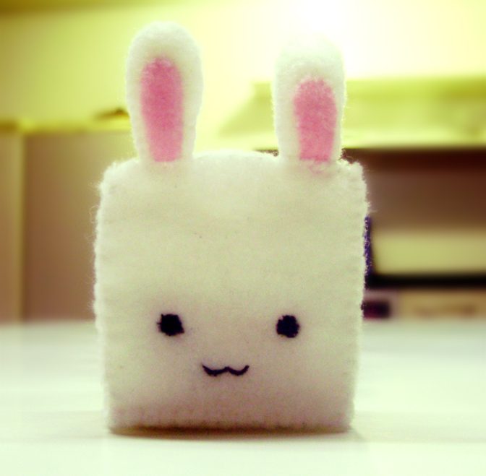

They resemble the general tone of the game and the protagonist Cubey, just drawn into an even cuter form.

They are pacifistic, innocent and very social.

They are white with black button-eyes and round-shaped long ears with pink inner-ears.  
Their face is positioned a little lower than usual to intensify the scheme of childlike characteristics.

Corrupted cube bunnies:

Have to resemble the pure cube bunnies, but are warped towards an evil aggressive and mentally unstable look.  
Their eyes are bright-red (cadmium red #E30022, which is a key feature of the corruption.  
Their ears are pointier and the inner ears are red (crimson #DC143C or venetian red #C80815; like the insides of their mouths, not their eyes – #E30022 ).

They exist in variants for multiple enemy types:

* White fur – the weakest form and barely corrupted – they use simple attacks that impose little threat
* Grey fur – a stronger form and more corrupted they shoot balls of the black corruptive liquid, fight more agile and impose medium threat
* Black fur – the strongest form and highly corrupted – they have a strong melee attack.